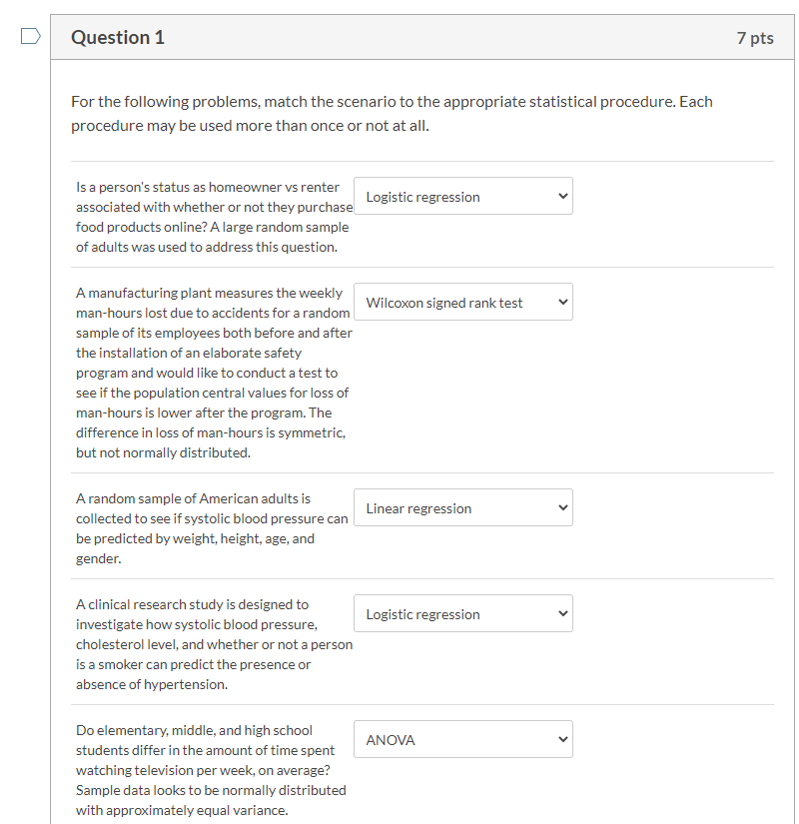

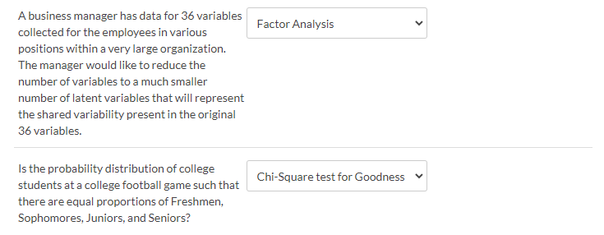

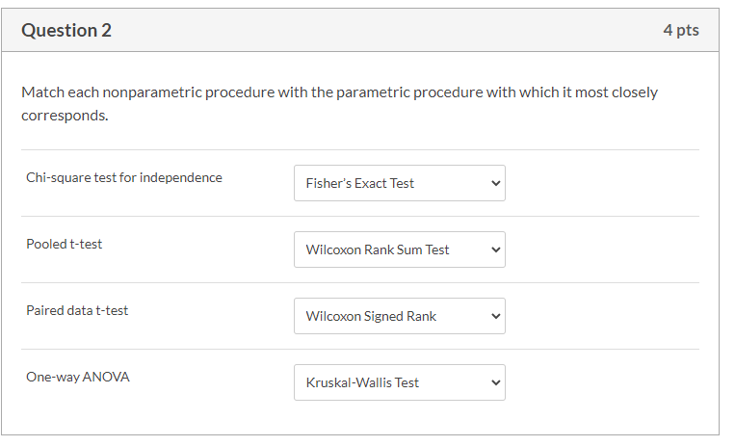

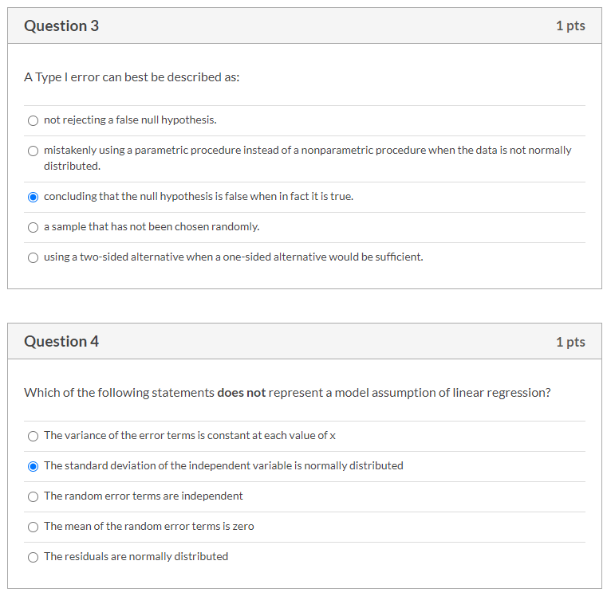

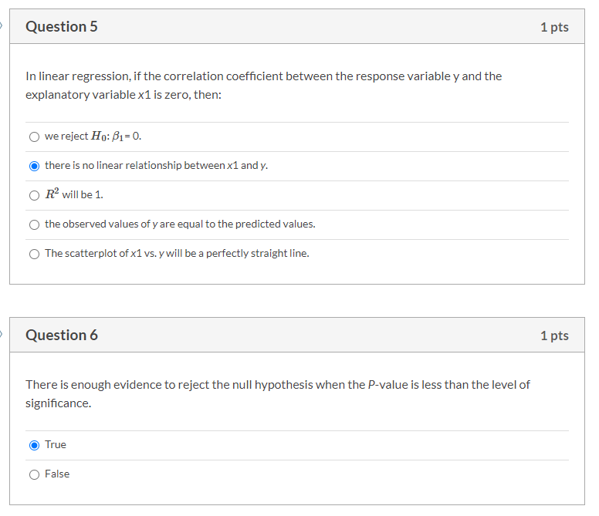

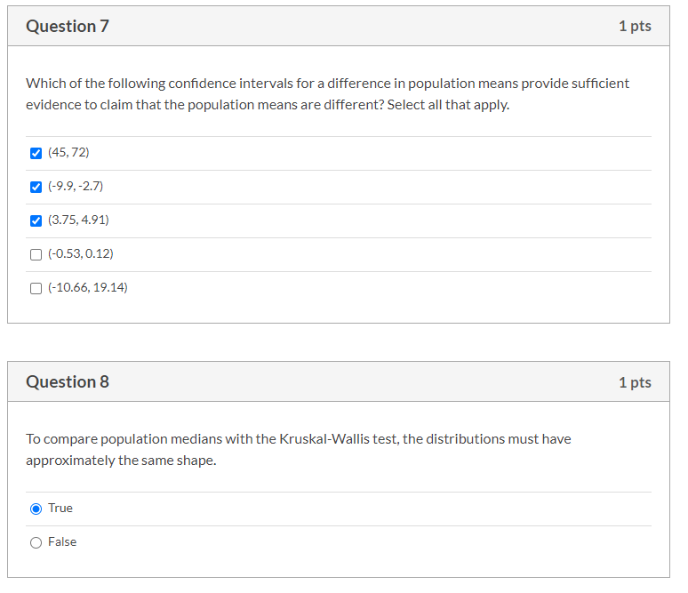

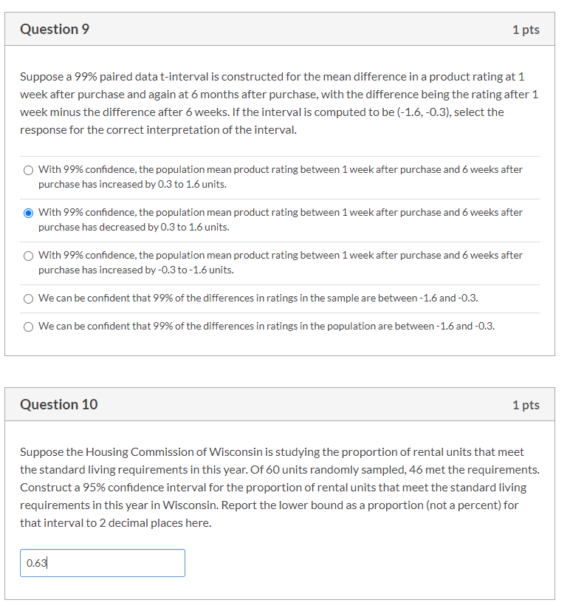

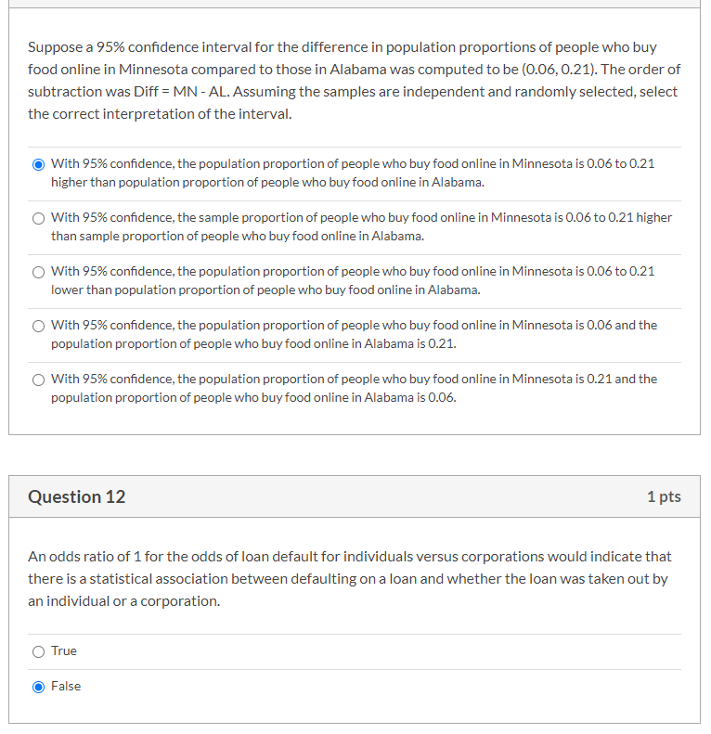

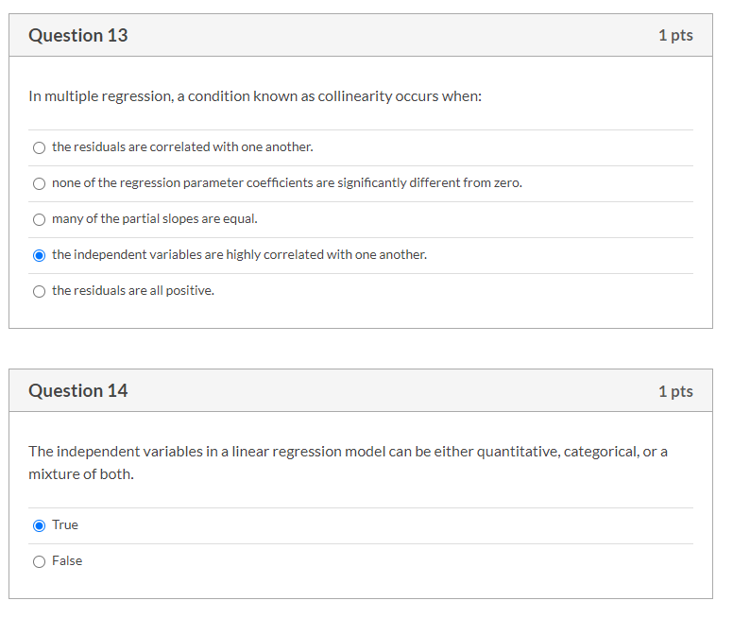

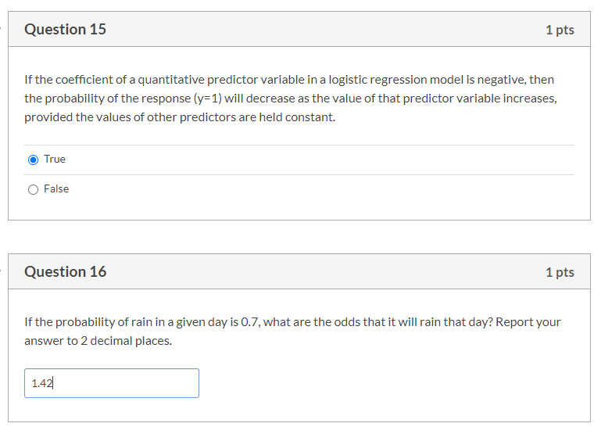

The normal feed chicken pecks appear to be distributed with a slight skew to the left since the boxplot’s median line is in the upper end of the IQR box. There are two outliers in this group, which makes the histogram a bit misleading.

The low sodium feed chicken pecks appear to be skewed to the right, with two outliers in this group.

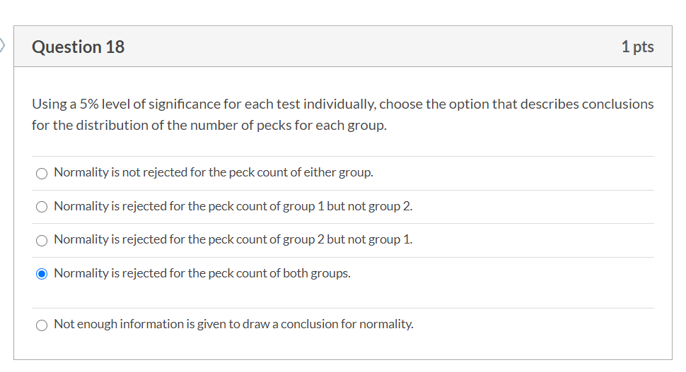

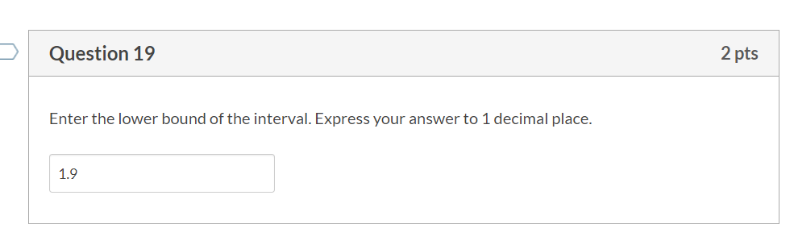

20. We are 90% confident that the median peck rate of chickens on a low sodium feed diet is 1.99 to 59.99 pecks greater than the median peck rate of chickens on a normal feed diet.

21. It was important to check assumptions about the data in order to generate appropriate confidence intervals for the difference in median peck rates between the two populations. The normally distributed assumption was not met, therefore we needed to use the Wilcoxon Rank Sum test and test shifts in distribution (vs. a normal t-test that would work when the data was normally distributed).

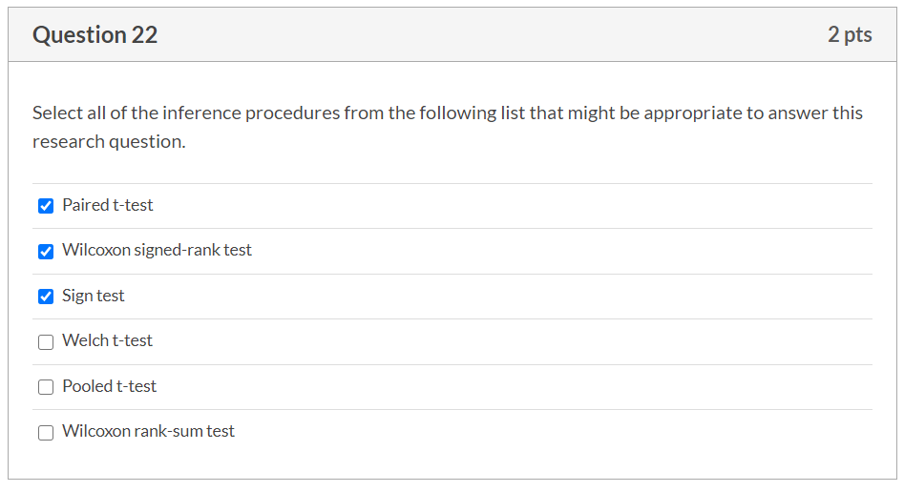

23) The data conditions we'll check for are as follows:

- Is the data from a random sample? Yes, the scenario given states this.

- Are the differences between the pairs of subjects normally distributed? Using a boxplot and histogram, the distribution appears normal and bell shaped. Conducting a shapiro test confirms normality (p-value = 0.6065).

With all that being said, we will use a paired t-test() for the inference procedure.

24) H_0: Strength training does not decrease 100m sprint times

H_a: Strength training does decrease 100m sprint times

t-statistic = -9.7539

Conclusion: At a 5% level of significance, there is enough evidence to claim that a 6-week strength training regimen does decrease 100m sprint times among college athletes (p-value=1.606e-11).

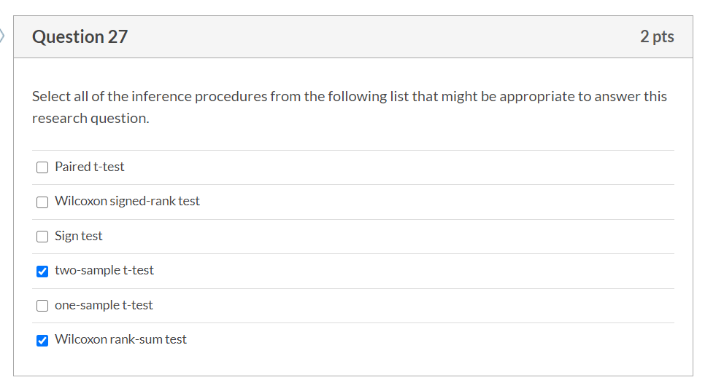

28) The data conditions we'll check for are as follows:

- Is the data from a random sample? Yes, the scenario given states this.

- Is the data from an independent sample? Yes, these are two separate populations per the scenario.

- Are the differences between the pairs of subjects normally distributed? Using a boxplot and histogram, the distributions appear normal and bell shaped. Group 2 does have a slight skew to the left. Conducting a shapiro test confirms normality for both group 1 (p-value = 0.7191) and group 2 (0.5876).

With all that being said, we will use a two sample t-test() for the inference procedure.

29) H_0: There is no difference between the population mean HLT score of college students who's team won a football game vs. the population mean HLT score of college students who's team lost a football game.

H_a: There is a difference between the population mean HLT score of college students who's team won a football game vs. the population mean HLT score of college students who's team lost a football game.

31)At a 5% level of significance, there is enough evidence to support that the population mean HLT score of college students who's team won a football game is different than the population mean HLT score of college students who's team lost a football game (p-value = 0.00591).

33) Because our test is concluding to "reject the null", we could be creating a type I error if the "null" is indeed true.

In the context of this problem, we are stating that the population mean HLT scores are different between the two populations, however if we encounter a type I error, then this means the that there truly is no difference in population mean HLT scores among the two groups.

35) We are 95% confident that the population mean HLT score for college students whose team lost a football match is between 81.03 and 94.83.

37) When looking at the boxplot, the 4 brand samples all appear to be symmetrically distributed, with brand A and B having an overall lower treadwear measurement, and brands C and D having an overall higher treadwear. The sample means of brands A, B, C, D are 576.30, 671.10, 825.98, 853.28 respectively.

Brand A appears to have the highest sample variance at 148.10, whereas  brand C appears to have the lowest at 57.85.  Brand B has a variance of 111.29 and Brand D has a variance of 81.23.  Overall, the brands do not appear to have equal variances.

We complete a shapiro test to test the normality of each of the brand's treadwear, and each test posits there is not enough evidence to reject the brands are not normally distributed - p-values for A, B, C, D are 0.3177, 0.1003, 0.4301, 0.3871 respectively.

38) H_0: There is no difference in population mean treadwear among tire brands A, B, C, and D

H_a: There is at least one difference in population mean treadwear among tire brands A, B, C, and D.

40) At a 5% level of significance, there is enough evidence to support the claim that there is at least one tire brand who's population mean treadwear is different than the other brand's population mean treadwear (p-value = 8.988e-10).

41) Because the samples do not have equal variance, i went with the Games-Howell test to compare multiple means and research the difference between groups (controlling for FWER).

We are 95% confident that the population mean treadwear for tire brand "C" is greater than the population mean treadwear for tire brands "A" and "B" by 151.79 to 206.48, and 78.39 to 231.36 mm (?) respectively.

We are also 95% confident that the population mean treadwear for tire brand "D" is greater than the population mean treadwear for tire brands "A" and "B" by 174.17 to 379.79, and 99.06 to 265.30 mm (?) respectively.